Scholarship Program Report – May 2019

Thanks to the generosity of you, our donors, Just Haiti supported the university studies of five agronomy students in the 2017-18 academic year and looks forward to supporting four additional students in the 2018-19 academic year.

Use of Funds:
Disbursed for 2018-19 academic year: $6,500
Remaining promised for program
completion: $10,000
Balance post disbursement: $8,000
Additional pledged by sponsors: $2,500

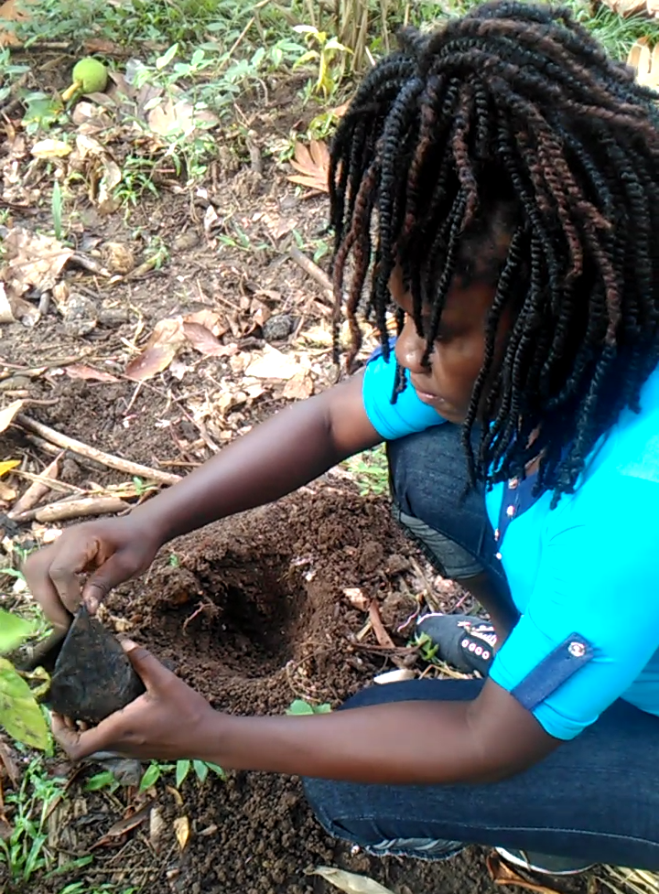

2017-18 Scholars:
Jimson Guerrier, Casimir Blanchet, and Marie Loudia Bruce represent KDB in the Baradères region.
Marie prepares seedlings for planting.
Jimson completed his fourth year of study and began his fifth year at the Université Notre Dame d’Haiti (UNDH) in Les Cayes this Fall 2018. Casimir and Marie completed their third year, attending UNDH-Les Cayes, and Université Episcopale d’Häiti in Port-au-Prince, respectively, and advanced to their fourth year after completing the 2017-18 academic year.

Dachna Doll, of the APPCA association in the Carcasse region, completed her fourth year in 2017-18 and enrolled in her fifth year of study at Université Episcopale d’Häiti this Fall 2018.

Jhon Jimmy Noel, representing the OPCDEL association in the Belladere region, completed his third year of agronomy studies at Université Quisqueya in Port-au-Prince in Fall 2018. Unfortunately, he will not continue his participation in 2019 due to academic deficiency.

Summer Internships:
This past summer, our students supported growers in the planting of seedlings and maintenance of nurseries in the Anse D’Hainault, Baradères, Belladere, and Leon regions. They also collaborated with our agronomist technician in educating growers in sustainable planting and seedling care practices.

New Scholars:
In Fall 2018 and Winter 2019, Just Haiti committed to four new first year students, three in agronomy, and one in business.

Jocelyn Dorce, our first participant from the Leogane association, began his agronomy studies at Université Americaine des Sciences Modernes d'Häiti in Port-au-Prince this Fall 2018.

Anse D’Hainault also has its first participants, Wilber Constant, Samuel Sainmerzier, and Joby Wilgreetchen Emile. Wilber and Samuel entered the local Université Nouvelle de Grand’Anse as agronomy students in Fall 2018. Joby began business studies at Université Quisqueya in Winter 2019.

For more information about our program, please contact us at scholarships@justhaiti.org.

